Animal Ethics
Change of Chief Investigator Form
2026

All applications are to be submitted in the IRMA system as attachments to a coversheet.
Use this form if the person nominated as Chief Investigator on a permit already approved by the Murdoch University Animal Ethics Committee (AEC) needs to change.
This is considered a Major Amendment and will be assessed at a meeting of the AEC.
The Chief Investigator is responsible for all aspects of a permit that uses live animals for scientific purposes and must consider the 3Rs: Replacement, Reduction, and Refinement at all times.
Chief Investigators are ultimately accountable and legally responsible for the wellbeing of all animals on a permit.
.

Animal Ethics Office
(08) 9360 6472 / 9360 7366
animal.ethics@murdoch.edu.au

Provide responses to ALL questions on this form.

Part 1 - Currently Approved Permit Information
1.1 | Permit Number (*****/**): |  |  |  |  |  | 1.2 | Protocol ID (***):
1.3 | Permit Title:
1.4 | Current Chief Investigator:
 | Title | Given Name |  |  |  | Surname
1.5 | Form completed by:
 | Date of completion:
 | Role on the project:
Part 2 - Change of Chief Investigator
Changing the Chief Investigator is a Major Amendment to a permit and must be reviewed at an AEC meeting.

Work cannot commence until AEC approval of Change of Chief Investigator has been received.
The Chief Investigator for a project must be a Murdoch University staff member or an approved adjunct who is able to take ultimate legal responsibility for the project.

The new Chief Investigator must ensure that:
- Co-investigators involved in the project understand and accept their ethical and legal responsibilities.
- Co-investigators will adhere to the permit’s stipulations at all times.
- Co-investigators are competent with respect to the wellbeing of the specific animals used in the project.
- Procedures and resources are in place so that everyone involved in the care and use of animals in the project can meet their responsibilities, including their education, training, and supervision.
2.1 | Title | Given Name |  |  | Surname
 | University School |  |  |  | Office No.
 | Telephone No. |  |  |  | Email
 | Has the new Chief Investigator completed ComPass and ACE Training? |  |  |  |  |  |  |  | Yes No
2.2 | What are the new Chief Investigator’s qualifications, training, and experience relevant to this permit?
2.3 | What are the new Chief Investigator’s responsibilities as they relate to this permit?
2.4 | Will the previous Chief Investigator remain on the protocol as a Co-investigator? |  |  |  |  |  |  |  | Yes No
2.5 | Provide details for the reason for the change in Chief Investigator.
2.6 | The Chief Investigator of each permit is nominated by default to complete the Annual Reporting requirements. Please advise if you wish to nominate an alternative Co-investigator for this role.
Part 3 - Legal Declaration of New Chief Investigator
3.1 | In accepting responsibility as Chief Investigator, I declare that:
 | University and Legislative Responsibilities:
 | - I understand and confirm that the permit approved by the Murdoch University Animal Ethics Committee (MU AEC) is a legal document that represents an independent and novel scientific project.
 | - I agree that I will conduct the research in accordance with the protocol approved by the MU AEC and in compliance with Murdoch University Policies, the Australian Code for the Care and Use of Animals for Scientific Purposes (‘The Code’, 8th Edition, NHMRC, 2013), the Western Australian Animal Welfare Act (2002), and the Australian Code for the Responsible Conduct of Research (NHMRC, 2007).
 | - I will ensure that written approval from the MU AEC is obtained before commencing on the project and before making changes to the project (e.g., changes to personnel, methods or animal numbers as described in the approved project).
 | - I will maintain written and digital documentation of all procedures carried out under an approved permit and will store these records for a period of 5 years following the project’s closure. I will produce these records upon request from the Animal Ethics Office and/or the Western Australian Regulator.
 | - I confirm that I am not guilty of any offence against Animal Act legislations in Australian States or Territories and I confirm that if this changes, I will inform the Animal Ethics Office immediately.
 | Responsibilities to Animals:
 | - I accept personal responsibility to ensure that all animals in this project receive humane and proper treatment in accordance with The Code (NHMRC, 2013), the Western Australian Animal Welfare Act (2002), and any other conditions stipulated by the MU AEC.
 | - I confirm that measures have been taken to ensure that animal housing, husbandry and care is appropriate for the species and will support animal wellbeing. This responsibility extends throughout the period of use approved by the AEC and may include the animals’ fate at the conclusion of use.
 | - I understand that the MU Animal Welfare Advisor must be notified of any adverse events, unexpected deaths, or euthanasia of animals under an approved permit within 48 hours (mobile no. 0447 061 593). Co-investigators / External investigators are also permitted to make these reports.
 | Responsibilities to Co-Investigators:
 | - I confirm that I have a clear line of communication with all co-investigators listed on the permit and I will ensure that all people involved in the care and use of animals in the project understand and accept their roles and responsibilities according to The Code (NHMRC, 2013).
 | - I will ensure that all investigators listed on the permit undertake any necessary education and training, including competency assessment, deemed necessary by Murdoch University and the AEC for scientific use of animals.
 | - I will provide all investigators with a copy of the approved permit application, the relevant State or Territory licence to use animals for science, and any other documentation necessary for legal conduct of research (e.g. animal monitoring sheets, collection licences, exemptions, training certificates).
 | - I will promptly inform all investigators about any changes made to the permit and approved by the MU AEC.
 | - I understand that the Animal Ethics Office must be notified of any events that disrupt, delay, prolong or otherwise impact the study described in the submitted application (office no. (08) 9360 6472 / 9360 7366). Co-investigators / External investigators are also permitted to make these reports.
 | RIGHT click on the signature box below and select ‘Sign’ to add your digital signature.
 | Name of Chief Investigator:
 | Signature:
 | Date:

Submission Information
for Animal Ethics forms

How to submit this form:
013

All forms are received and processed through the IRMA system. To do this, you will need to create a “Coversheet” in IRMA and attach this form and any supporting documents as part your submission.


- Begin by creating a Coversheet. Log into IRMA and click on “Researcher Profile” (found in the top right-hand corner of your screen). If you do not have IRMA access, lodge a request with IT through ServiceNow.

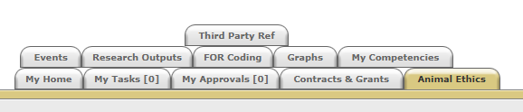

- Click on the “Animal Ethics” tab:

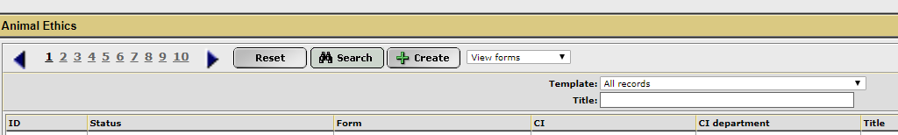
- Ensure the drop-down option is showing as “View Forms”, and click the “Create” button to create a new coversheet:

- Select the Change of Chief Investigator coversheet from the drop-down list (shown below), link the coversheet to the relevant project by clicking the “Search” button, and then click “Next”:
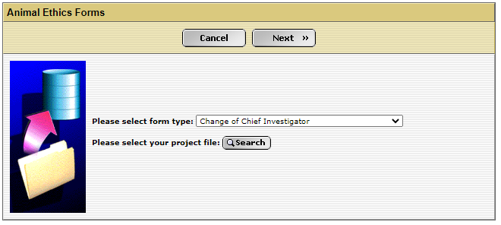

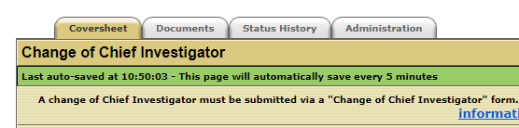
- A new screen will appear (see below). Click on the weblink and download the “Change of Chief Investigator” form.

- When this form is complete, save the document to your computer and upload a copy into the IRMA coversheet. Click on the “Documents” tab (shown in 5. picture) and upload the form by clicking the “+ Add” button. Ensure each attachment is clearly labelled when uploading.

- Once this form has been uploaded into IRMA, return to the “Coversheet” tab, and click the “Submit” button.
TASK COMPLETE

