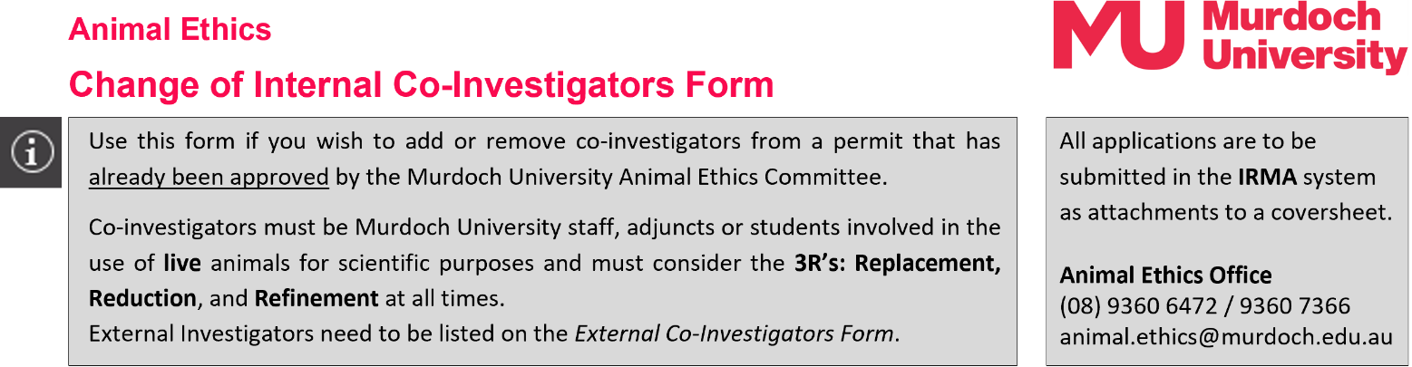

Provide responses to ALL questions on this form.

Part 1 – Currently Approved Permit Information
1.1 | Permit Number (*****/**): |  |  |  |  |  |  |  |  | 1.2 |  | Protocol ID (***):
1.3 | Permit Title:
1.4 | Chief Investigator:
 | Title |  |  |  | Given Name |  |  |  |  |  | Surname
1.5 | Form completed by:
 | Date of completion:
 | Role on the permit:
Part 2 – Changes to Internal Co-Investigators at Murdoch University
2.1 |  | If removing Murdoch University Co-Investigators, complete the following:
 |  |  | Title and Full Name |  |  |  |  |  | Role / Responsibilities on permit pertaining to live animal use
 |  | Co-I 1
 |  | Co-I 2
 |  | Co-I 3
 |  | Co-I 4
 |  | Co-I 5
 |  | Co-I 6
 |  | Co-I 7
 |  | Co-I 8
2.2 |  | If adding new Murdoch University Co-Investigators, complete the following:
 |  | Co-Investigator 1:
 |  | Title |  |  | Given Name |  |  |  |  | Surname
 |  | University School |  |  |  |  |  |  |  | Office No.
 |  | Telephone No. |  |  |  |  |  |  |  | Email
 |  | Has the new Co-Investigator completed ComPass and ACE Training? |  |  |  |  |  |  |  |  |  |  |  |  | Yes No
 |  | Co-Investigator 2:
 |  | Title |  |  | Given Name |  |  |  |  | Surname
 |  | University School |  |  |  |  |  |  |  | Office No.
 |  | Telephone No. |  |  |  |  |  |  |  | Email
 |  | Has the new Co-Investigator completed ComPass and ACE Training? |  |  |  |  |  |  |  |  |  |  |  |  | Yes No
 |  | Co-Investigator 3:
 |  | Title |  |  | Given Name |  |  |  |  | Surname
 |  | University School |  |  |  |  |  |  |  | Office No.
 |  | Telephone No. |  |  |  |  |  |  |  | Email
 |  | Has the new Co-Investigator completed ComPass and ACE Training? |  |  |  |  |  |  |  |  |  |  |  |  | Yes No
 |  | Co-Investigator 4:
 |  | Title |  |  | Given Name |  |  |  |  | Surname
 |  | University School |  |  |  |  |  |  |  | Office No.
 |  | Telephone No. |  |  |  |  |  |  |  | Email
 |  | Has the new Co-Investigator completed ComPass and ACE Training? |  |  |  |  |  |  |  |  |  |  |  |  | Yes No
If there are more than 4 Co-Investigators, complete multiple versions of this form,
and attach each under the DOCUMENTS tab in IRMA.
2.3 |  | List the specific responsibilities of each new Co-Investigator as they relate to live animal use on this permit. Please identify any students involved in the project.
 |  | Specific Responsibilities on Project:
 |  | Co-I 1
 |  | Co-I 2
 |  | Co-I 3
 |  | Co-I 4
2.4 |  | List the relevant experience, training and qualifications related to the responsibilities of each co-investigator.
Briefly summarise how they are appropriate to the procedures to be performed and species to be used.
The AEC will use this information to assess suitability of personnel to perform relevant procedures under this permit.
 |  | Experience, Training, Qualifications etc.
 |  | Co-I 1
 |  | Co-I 2
 |  | Co-I 3
 |  | Co-I 4
2.5 |  | Identify any training needs and indicate how these will be provided.
Part 3 – Legal Declaration for New Co-Investigators at Murdoch University
3.1 | By accepting the responsibility of a Co-Investigator, I declare that:
 | - I confirm that I will conduct the research in accordance with the protocol as approved by the Murdoch University Animal Ethics Committee (MU AEC) and in compliance with the 8th Edition of the Australian Code for the Care and Use of Animals for Scientific Purposes (‘The Code’, NHMRC, 2013) and the Australian Code for the Responsible Conduct of Research (NHMRC, 2007).
 | - I confirm that I am not guilty of any offence against Animal Act legislations in Australian States or Territories and I confirm that if this changes, I will inform the Animal Ethics Office immediately.
 | - I am fully informed about the project listed above, including my role in the project and knowledge of the associated ethical issues and potential impacts on animals.
 | - I confirm that I have a clear line of communication with the Chief Investigator and co-investigators listed on the research/teaching permit for animal use in science.
 | - I will confirm with the Chief Investigator that written approval from the MU AEC has been obtained prior to commencing on the project and before making any changes to the project (e.g., changes of personnel, methods or animal numbers as described in the approved project).
 | - I will undertake any necessary education and training, including competency assessment, deemed necessary by Murdoch University and the AEC for scientific use of animals.
 | - I will ensure that any procedures on animals under my care will comply with the permit’s stipulations and be performed competently and with respect for animal sentience.
- I will notify the MU Animal Welfare Advisor of any adverse events, unexpected deaths, or euthanasia of animals under my care within 48 hours (mobile no. 0447 061 593).
All investigators are permitted to make these reports.
 | - I understand that the Animal Ethics Office must be notified of any events that disrupt, delay, prolong or otherwise impact the study described in the submitted application (office no. (08) 9360 6472 / 9360 7366). All investigators are permitted to make these reports.
 | RIGHT click on the signature boxes below and select ‘Sign’ to add your digital signature.
 | Name of Co-Investigator 1:
 | Signature:
 | Date:
 | Name of Co-Investigator 2:
 | Signature:
 | Date:
 | Name of Co-Investigator 3:
 | Signature:
 | Date:
 | Name of Co-Investigator 4:
 | Signature:
 | Date:

Submission Information
for Animal Ethics forms

How to submit this form:
013

All forms are received and processed through the IRMA system. To do this, you will need to create a “Coversheet” in IRMA and attach this form and any supporting documents as part your submission.


- Begin by creating a Coversheet. Log into IRMA and click on “Researcher Profile” (found in the top right-hand corner of your screen). If you do not have IRMA access, lodge a request with IT through ServiceNow.

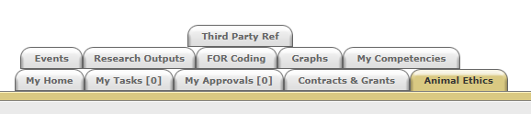

- Click on the “Animal Ethics” tab:

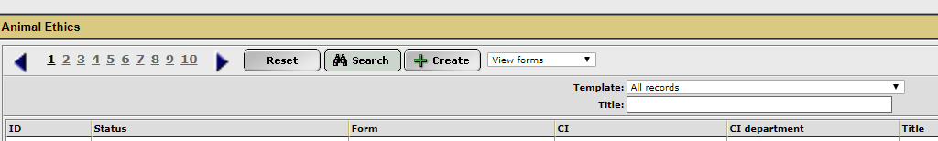
- Ensure the drop-down option is showing as “View Forms”, and click the “Create” button to create a new coversheet:

- Select the Changes to Co-Investigator team coversheet template from the drop-down list (shown below), link the coversheet to the relevant project by clicking the “Search” button, and then click “Next”:
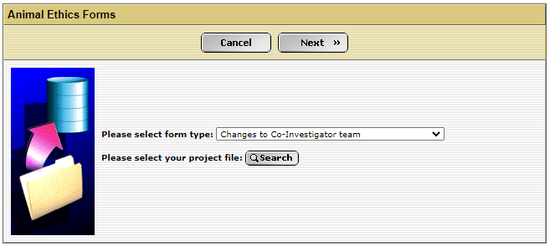

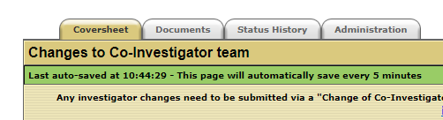
- A new screen will appear (see below). Click on the weblink to access the Change of Co-Investigator form.

- When this form is complete, save the document to your computer and upload a copy into the IRMA coversheet. Click on the “Documents” tab (shown in 5. picture) and upload the form by clicking the “+ Add” button. Ensure each attachment is clearly labelled when uploading.

- Once this form has been uploaded into IRMA, return to the “Coversheet” tab, and click the “Submit” button.
TASK COMPLETE

